Introduction
This promotional kit will help you take part in and promote GambleAware Week 2022. There are plenty of ways to get involved using the assets we have created.

This promotional kit contains:

- the plan for GambleAware Week 2022
  - key messages
  - how to promote the week – including social media and media engagement.

What is GambleAware Week?
GambleAware Week is an annual initiative to increase the awareness of gambling and gambling harm in the NSW community. It is an opportunity to:

- increase the community’s understanding of risky gambling behaviour
- encourage gamblers to recognise when their gambling may place them at risk of harm
- provide information on practical ways to keep their gambling under control
- provide information on how to get support.

To make sure everyone in our community is GambleAware, the campaign relies on the support of our valued stakeholders to share the campaign messages and resources through their own networks and to raise awareness in their organisations and local communities.

GambleAware Week 2022

The theme and key messages

The theme for 2022 is What’s Gambling Costing You? Key messages in this year’s campaign address the impact gambling can have on our relationships, career, finances and wellbeing. Gambling harm looks different for everyone, so we want to ask the question this GambleAware Week, ‘What’s Gambling Costing You?’.

Our promotion

The campaign will be promoted with paid advertising on social media, radio and streaming services. We will also be rolling out a public relations program to get media coverage.
We can take care of this side, but we need your help in spreading the message even wider across the whole state. That’s where you and this kit can help.

How you can promote GambleAware Week 2022

We have created a range of assets so that you can promote GambleAware Week. These are all loaded on our website for download and use.

You can display our posters and digital screens in your office, venue or approved public space, post our videos to your social media, or use our newsletter headers to send information out to your stakeholders. We’d love you to share everything! Please also encourage your network to promote GambleAware Week to their networks and communities.

Assets available and how to use them

Posters in A3 & A4.
- Print at home or in the office and display or send to a professional printer for high quality posters

Videos (15 and 30 second)
- You can use these videos for social media

Email signatures
- Use these to let people know it is GambleAware Week. Don’t forget to link it to https://www.gambleaware.nsw.gov.au/resources-and-education/gambleaware-week

Digital screens
- These are available in landscape and portrait layout

Digital banners
- Use on your websites, on social media and in digital communications

All of these assets are available on the GambleAware website for you to easily download and use. Please contact carmen.moller@responsiblegambling.nsw.gov.au if you have any questions.

Social media tips

Social media is a great way to promote GambleAware Week. Here are some tips on how to get the most out of your posts. It doesn’t matter if you use our campaign assets or your own. You can:
- Post often. You should post:
- early – let everyone know GambleAware Week is coming up
- during key social viewing times (lunchtimes and after dinner)
- Where possible, link the post back to the GambleAware website www.gambleaware.nsw.gov.au
- Tag us on Facebook and Instagram using @GambleAwareNSW. Add hashtags #GambleAwareWeek #GambleAware and #GambleAwareWeek2022 to your posts so we can see them and share them.

Social media posts

Here are some examples of copy for social media posts. You can use the copy as it is or adapt the copy to suit your organisation. The social media assets as pictured, as well as the social media story assets are available for download on the website.

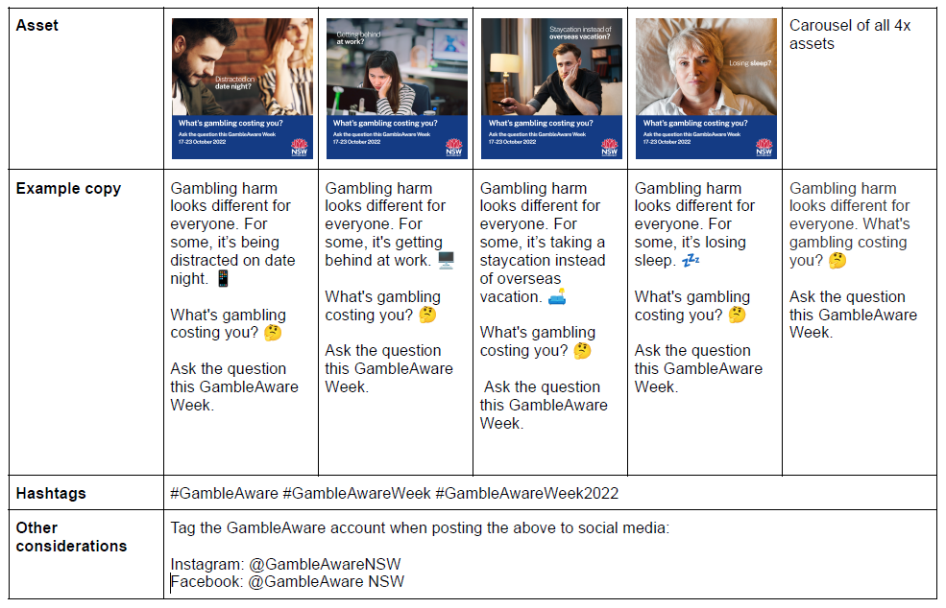

Media management
Media interest in GambleAware Week is growing every year. We will be dealing with media across NSW to get coverage and we encourage you to reach out to your local outlets. Here are some tips on how to do this as well as a customisable media release template for your use.

Preparing your media release

We have provided a media release template which you can send to local media outlets. All you need to do is customise it to your needs and include a quote from your representative, if relevant.

You are also welcome to create your own media release. If you do, please:

- ensure your messaging is consistent with the GambleAware objectives
- use a positive and creative tone
- use clear, simple language
- summarise the key points about GambleAware Week and your activity/service
- include a quote from a spokesperson from your service. Ensure they have approved the quote.
- don’t go over one page.
- include a photo if you can – media are more likely to use a story if they have an image to go with it.

Sending your media release

Local media will be the most interested in covering your story. Here are our suggestions:

- Research local publications or media outlets that cover your area and find out their publishing deadlines.
- Find contact details for the editor or journalists. You can usually find their details on their website or call reception and they can provide you the news desk’s general email.
- Email the media release to the editor or journalist, then follow up with a phone call the next day if you haven’t heard from them. Here is an example.

Introduction script example:

"Hi, this is [Name] calling from [company].

GambleAware Week this year is from October 17 – 23, and [organisation] is helping to raise awareness of gambling and gambling harm in the community.

Key points about your service (location, number of clients), how you are supporting the week.

If any photo opportunities or special guests/speakers
We think this might be of interest to your [readers/listeners/viewers] and would love to [see/hear] a piece about GambleAware Week [on/in media name].

I have a media release to send you and would be happy to provide any additional information. Who is the best person to speak to or to send my release?

When to contact the media

Publication Frequency | How far out from deadline to contact
Daily | 3-4 days prior to the day you want your story to appear
Weekly | 4-5 days before their deadline for the next week’s publication

TV and radio stations
If you are doing any TV or radio media, please let the Office know so we can track the interviews and find the articles as we have a media monitoring system in place. You can use your own spokespeople, or we can help suggest one if you prefer. Contact carmen.moller@responsiblegambling.nsw.gov.au

Don’t forget to provide speakers with the key messages below to ensure the GambleAware Week message is consistent across the state.

Media Release Template
You are welcome to use the template on the following page. All you need to do is insert the details of your organisation and location. There are quotes provided that keep the message consistent, but these can be edited to reflect your organisation and perspective as appropriate.

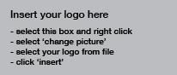

MEDIA RELEASE
Education a key focus this GambleAware Week

Monday, 17 October 2022

GambleAware Week is underway again this year, with a focus on the costs of gambling and education initiatives for parents, teachers and the <community/region/area location> The theme for this year’s GambleAware Week is ‘What’s gambling costing you?’ and looks at the potential costs of gambling on our health, our relationships, and at work.

<insert lead local service provider name and location> says we often hear reports on the amount of money lost on gambling, but the cost is more than just financial. “Although many people gamble without experiencing harm, it can come at a cost which might be unrealised. A key focus for GambleAware Week has always been about starting those early conversations, and this year we really want the <community/region/area location> to think about the real cost of gambling.

“We know that these costs can build up over time, so it’s important that we talk with our friends, family or colleagues if we are worried about what gambling could be costing them,” Mr/Ms/Mrs Last name of spokesperson said.

Parents in particular are encouraged to be aware of the risks for young people, with a number of education programs now available in the <community/region/area location> to help parents and the community minimise the risk of gambling harm.

Mr/Ms/Mrs Last name says that young people are becoming more and more exposed to gambling, so it’s important there are tools and resources available to help support parents or guardians understand the risk.

“The harm young people may experience could result from financial impacts of sports betting or the gambling-like elements in video games. Young people are also increasingly exposed to pervasive gambling advertising, through social media and other digital platforms and when watching sport.

“Education is needed for the entire <community/region/area location>, including those who may not currently experience challenges around gambling and yet may be in a position to help others.”

<Any info here about local activities/programs/educational initiatives being held in GambleAware Week by local service provider>

GambleAware Week runs from Monday, 17 October – Sunday, 23 October. Resources, including information about online training and education programs are available at www.gambleaware.nsw.gov.au

The GambleAware phoneline 1800 858 858 is open 24 hours a day for anyone needing support. It is free and confidential. Otherwise, call your local GambleAware service provider <name of local service provider>, on phone <number>.

Contact for media requests: Name, phone number (mobile recommended)

For more information and to share your results

Thank you, and good luck with your GambleAware Week 2022 activity.

Please contact carmen.moller@responsiblegambling.nsw.gov.au or anyone else in the team if we can provide any help or support during GambleAware Week.

Please also get in touch to share your activities and results from the week so that we can capture all the action in our evaluations and reports.

